A short history of Refugees in the U.S.

A government shutdown is currently plaguing the United States. The main point of contention? Immigration. Here is a data-driven approach to shed some light on refugee admissions in the United States.

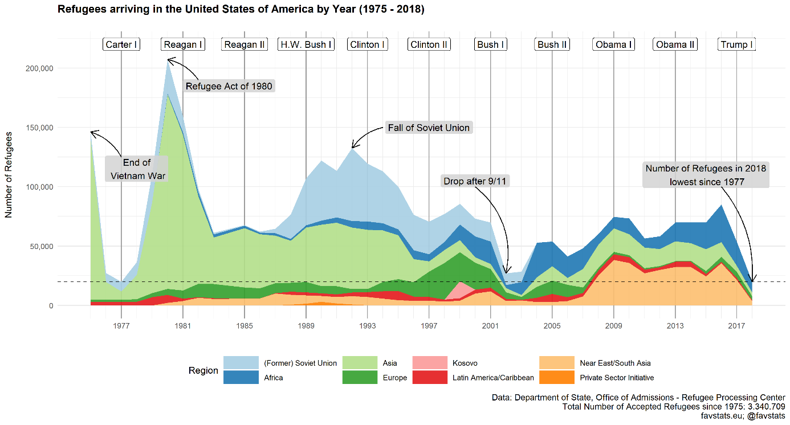

Here’s a long-term view of refugees in the United States. Refugee admissions peaked in 1981 with the Refugee Act of 1980.

[Write something about the Refugee Act of 1980]

Most refugees at the time came from Asia and more specifically (which Country)?

1986 refugees from the Soviet Union and regions of the east bloc started coming in they peaked in 1992, the year the Soviet Union fell, with a total of 140.000 admitted refugees that year.

A next focus is the drop after 9/11. Bush enacted such and such which led to a sharp drop in 2002.

In the years after, the number slowly to an average of roughly 75.000 refugees per year. This all changed in 2016 with the election of Donald Trump. Travel ban and other things led to a sharp decline in admitted refugees and the Trump administration broke two low number records in a row. In 2018, the U.S. admitted the lowest number of refugees since 1977.

That is where we are now.

**Who are the refugees?**

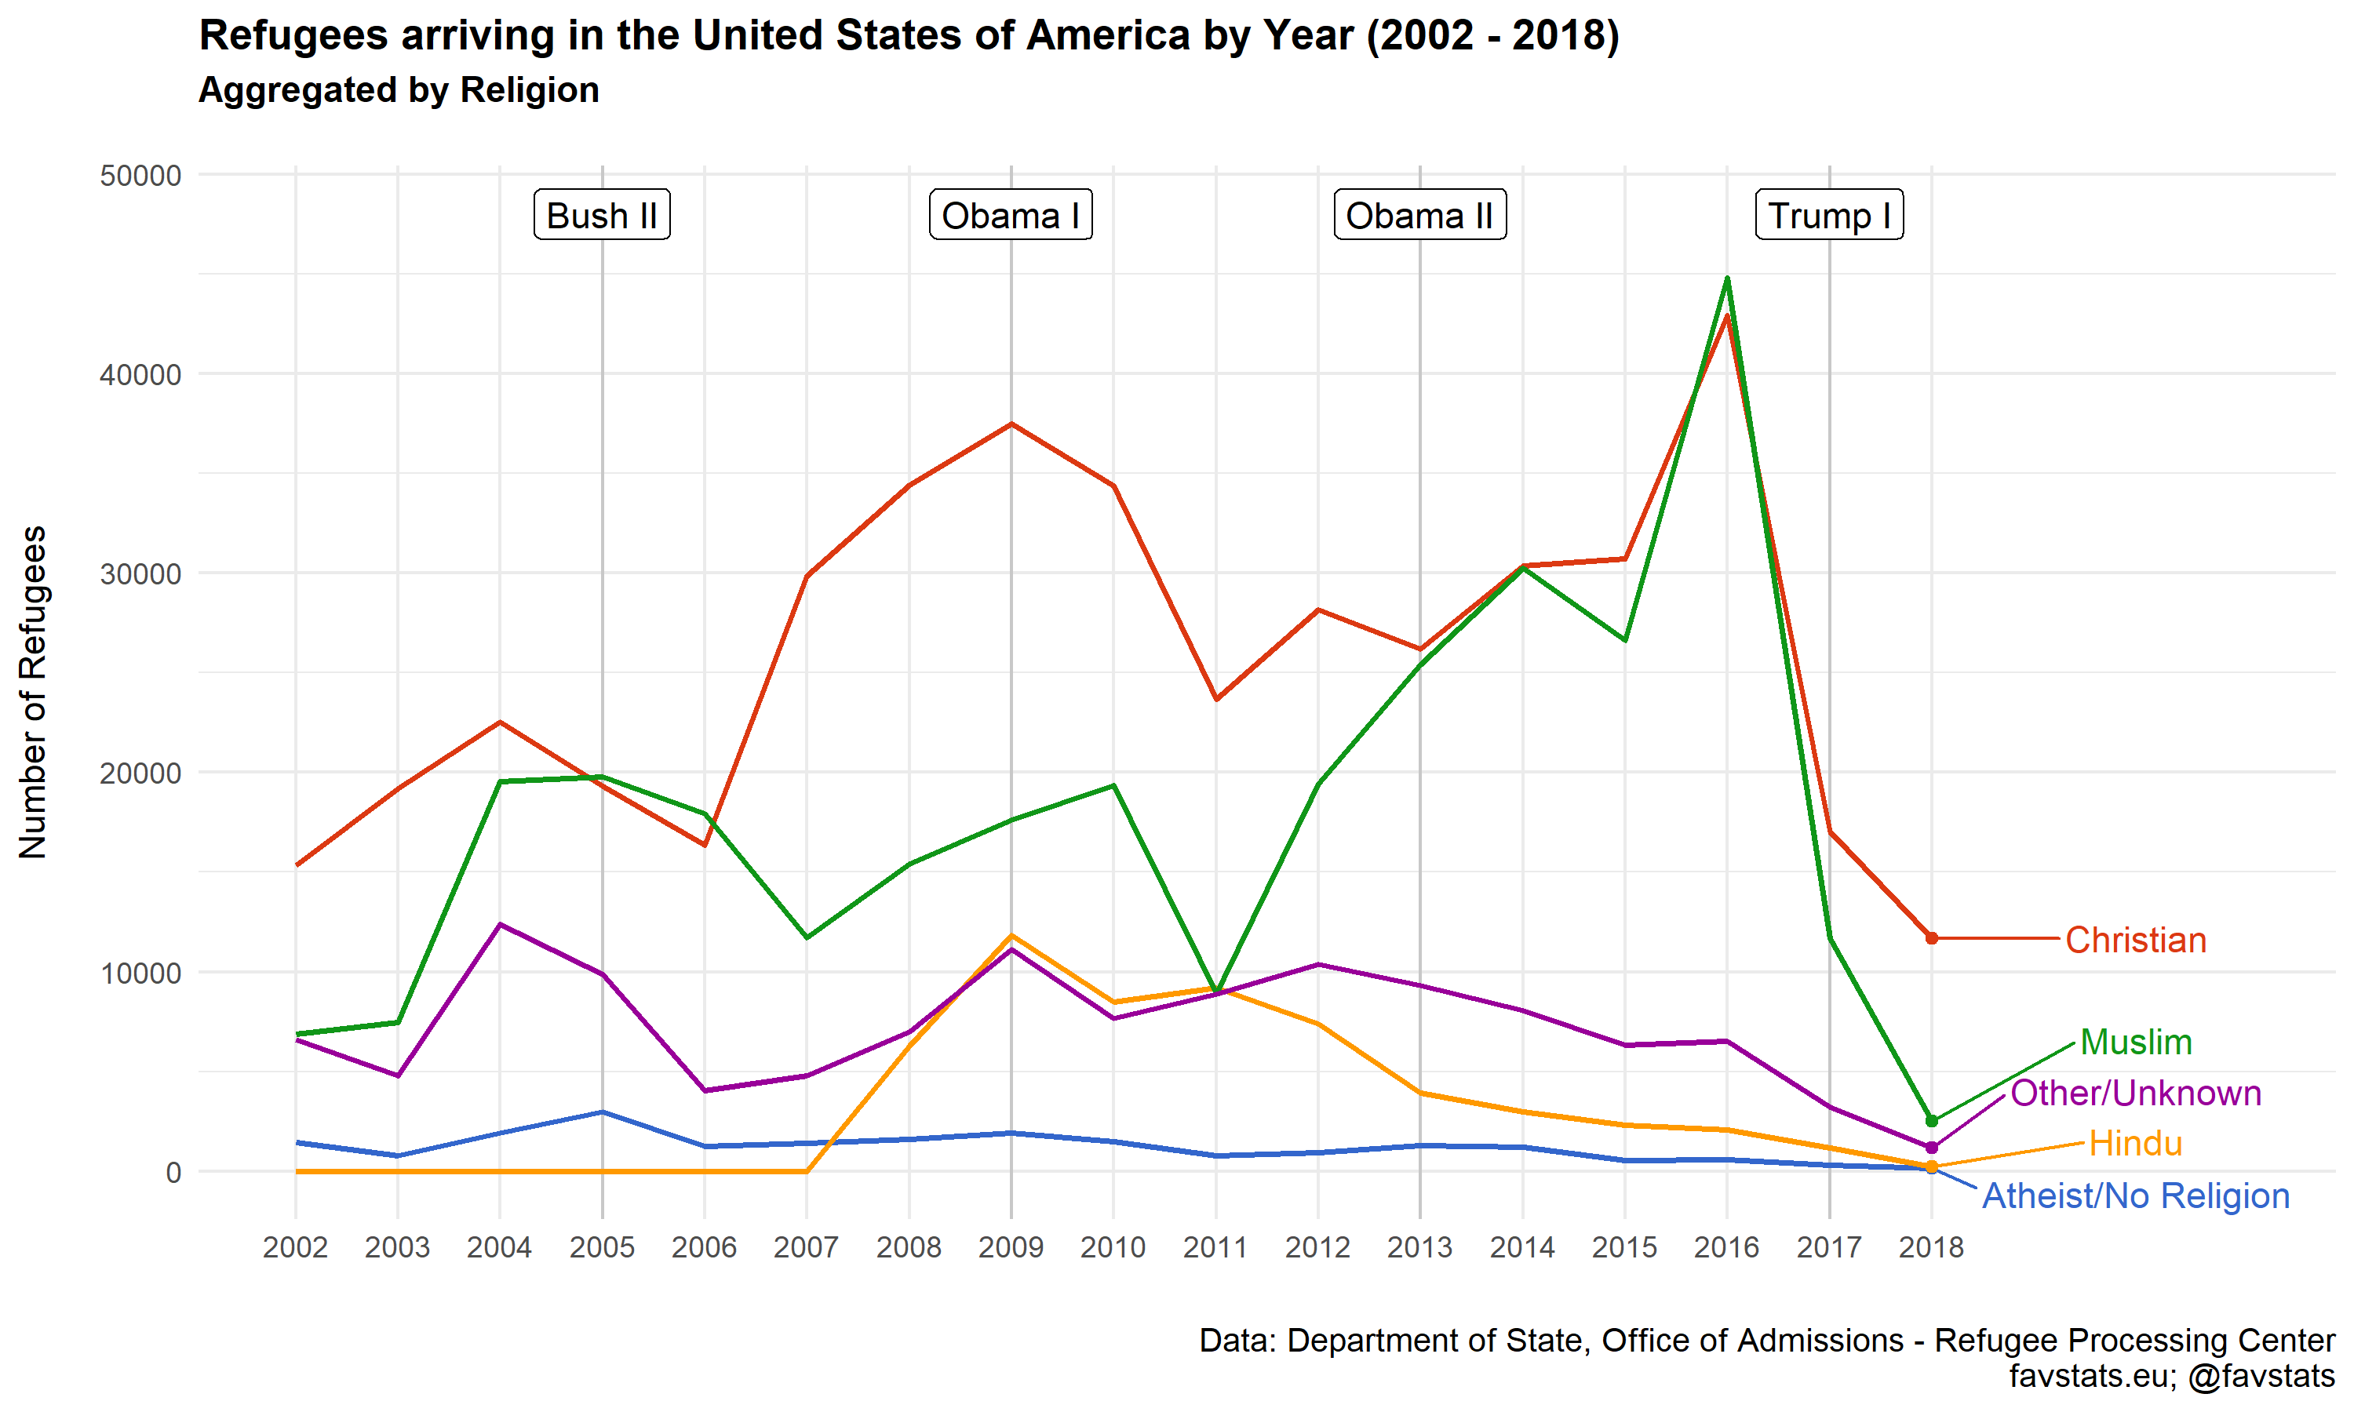

The state department provides us with some demographic information about the refugees from 2002 onwards. Except for three years (2005, 2006 and 2016) most of the admitted refugees in each year were Christian. Here too we can see a sharp decline once the Trump administration came in to power in 2017.

**Where do refugees come from?**

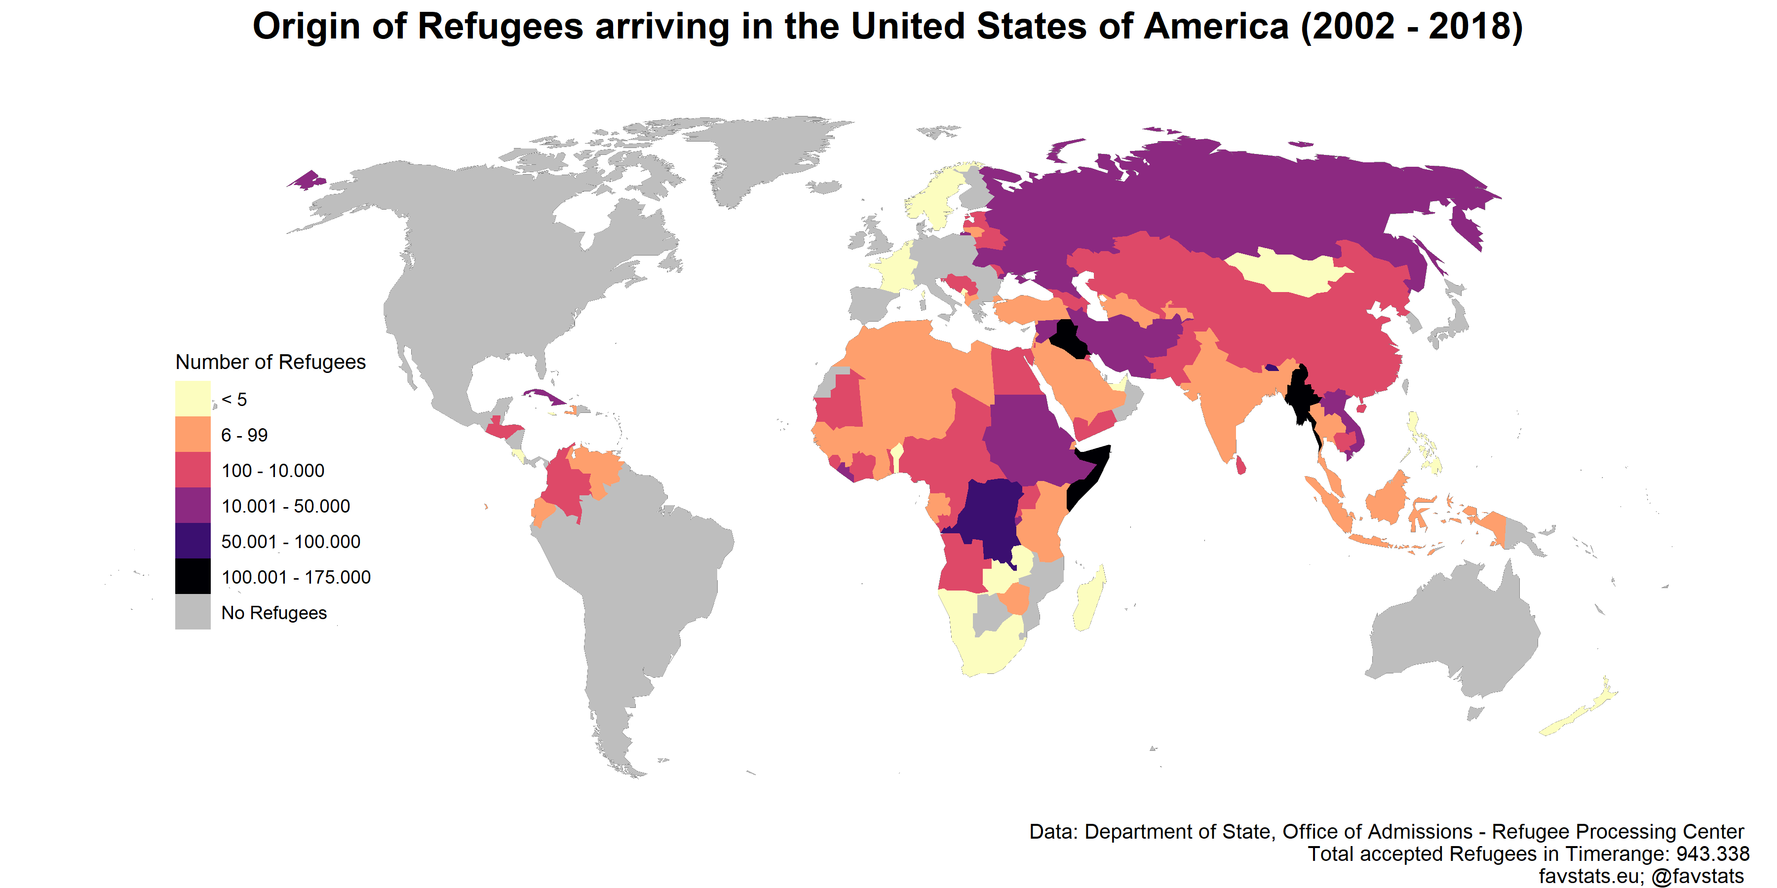

Given the current crisis at the border, one might expect that there are a bunch of refugees from the South America. A look at the data though, reveals that the U.S. barely takes any refugees from South America. Why is that the case? One can only guess at this point.

The highest number of refugees from 2002 to 2018 came from Somalia, Iraq and Myanmar followed by the Congo. Percentages? Events?

**Where do refugees go?**

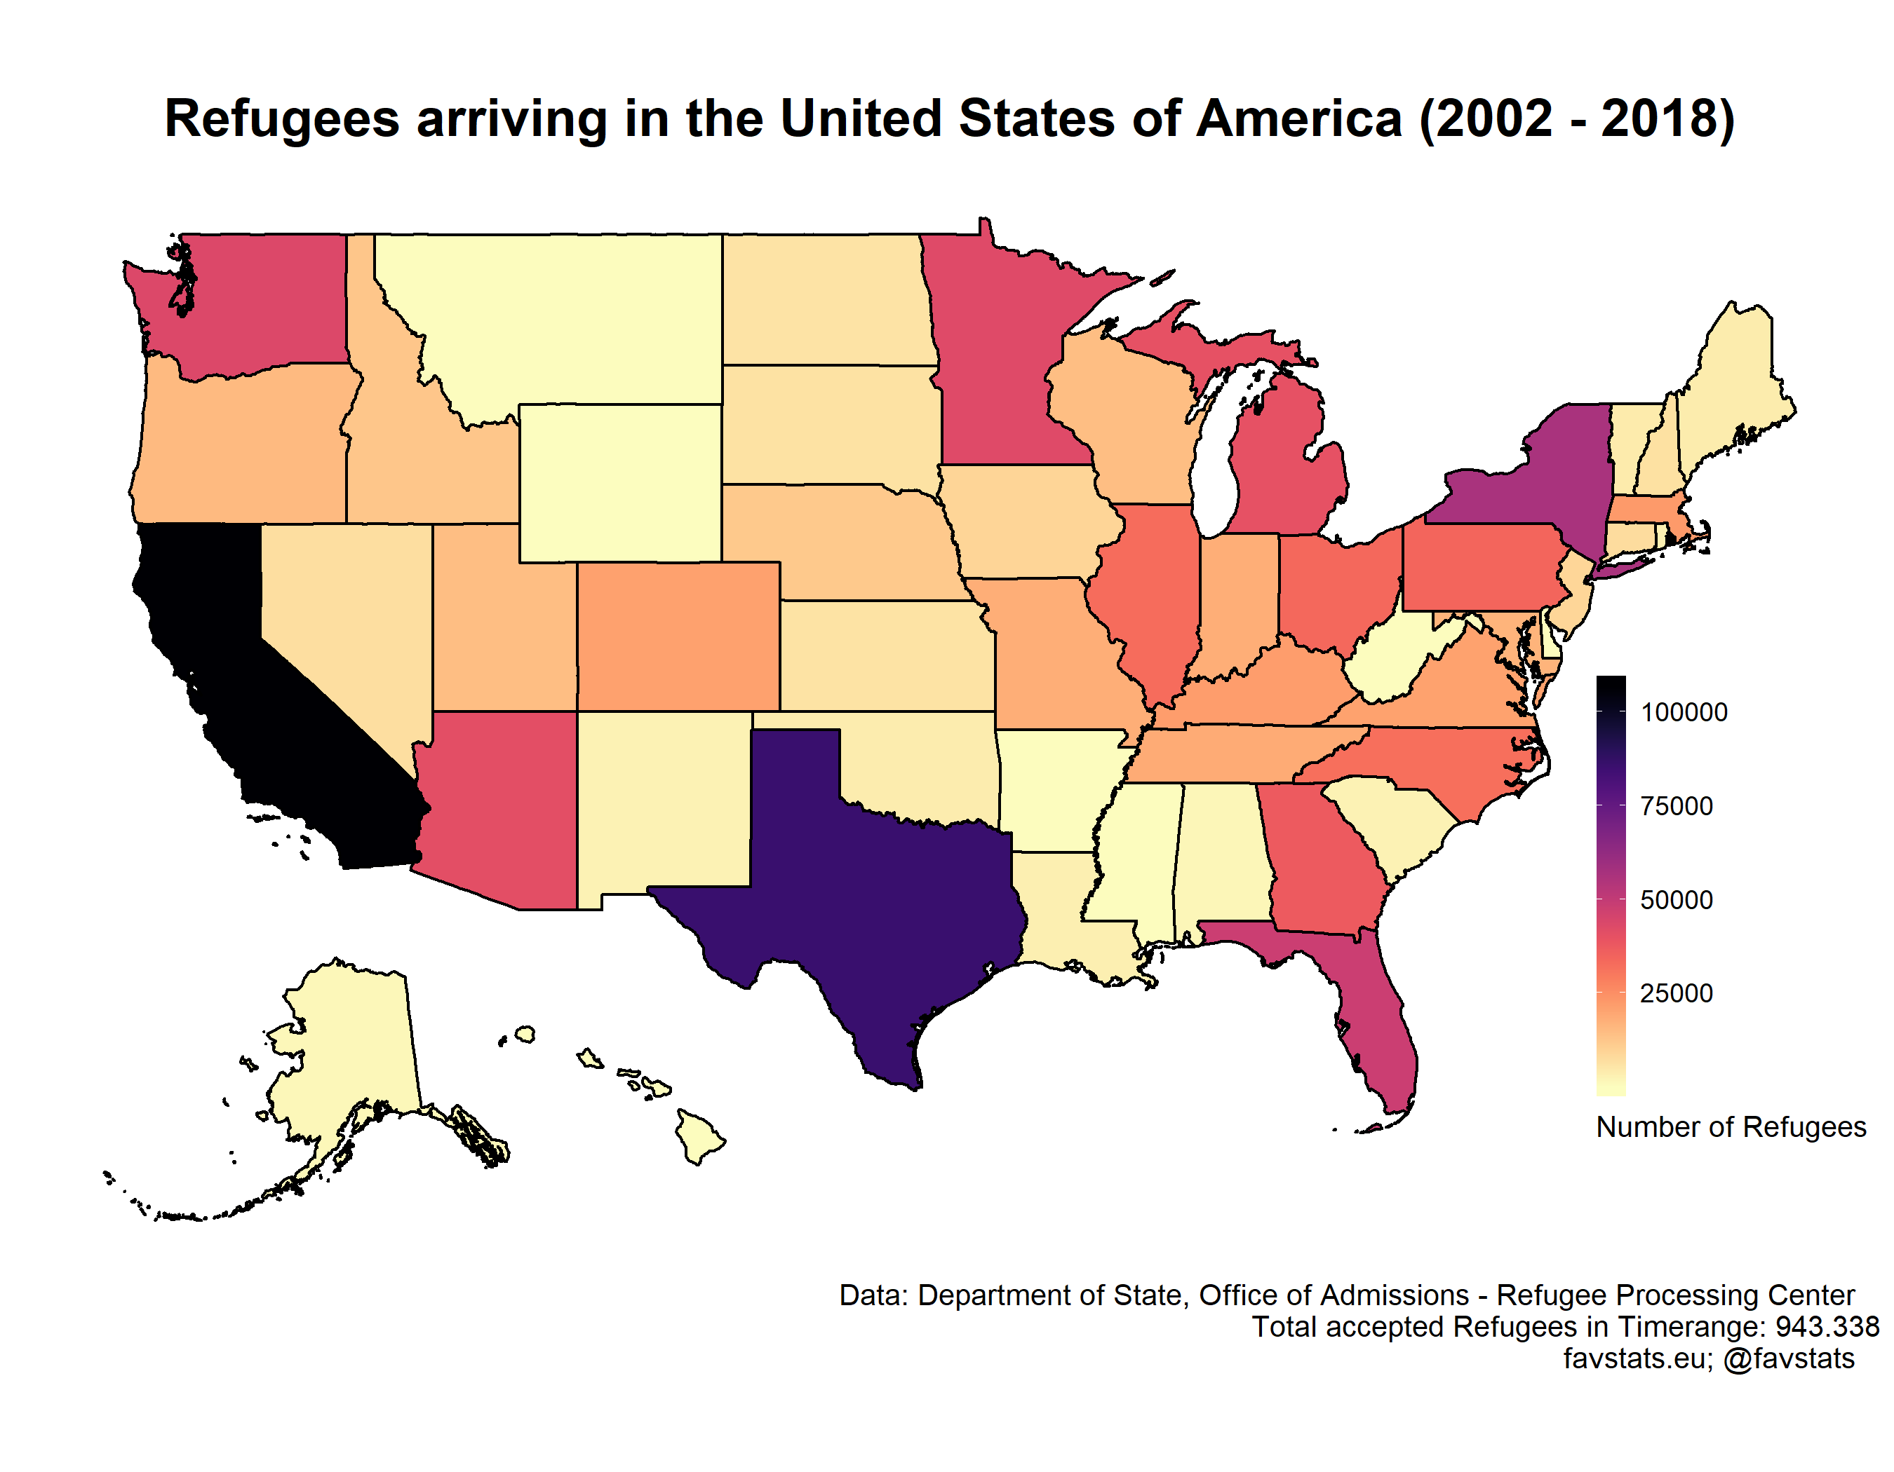

Finally, one can ask where the admitted refugees will go. Most refugees from 2002 to 2018 were admitted in California. Almost 10% of all refugees were admitted there. Not very surprisingly, the Midwest took in the fewest number of refugees.

By county? Add cities?

